###### DESCON ENGINEERING LIMITED

DESCON

Descon Head Quarter 18-Km, Ferozepur Road,

P.O. Box 1201, Lahore 53000 Pakistan

Phone: +92(042) 5805134

Universal Access: +92 111 DESCON

Fax: +92(o42) 5811005, 5811135

E-mail: descon@descon.com.pk Website: www.descon.com.pk

# P

## SERVICE CERTIFICATE

Certified that Mr.

S/O Mr.

***<Name>***

***<fname>***

Has served the Company as

***<Designation>***

Employee No . ***53-2245*** at

**PAKISTAN PTA LIMITED**

from <From2> to <To2>

**PROJECT MANAGER**

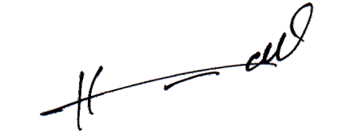

DESCON

**C**